MAC Users
- Download: MAC App
  - It is a condensed folder, contents need to be extracted
  - Then, open/install file name: Timex1.1.0.1(95).pkg

PC Users
First, you need to determine if you are running a 32bit or 64bit system.
Start Button > Computer
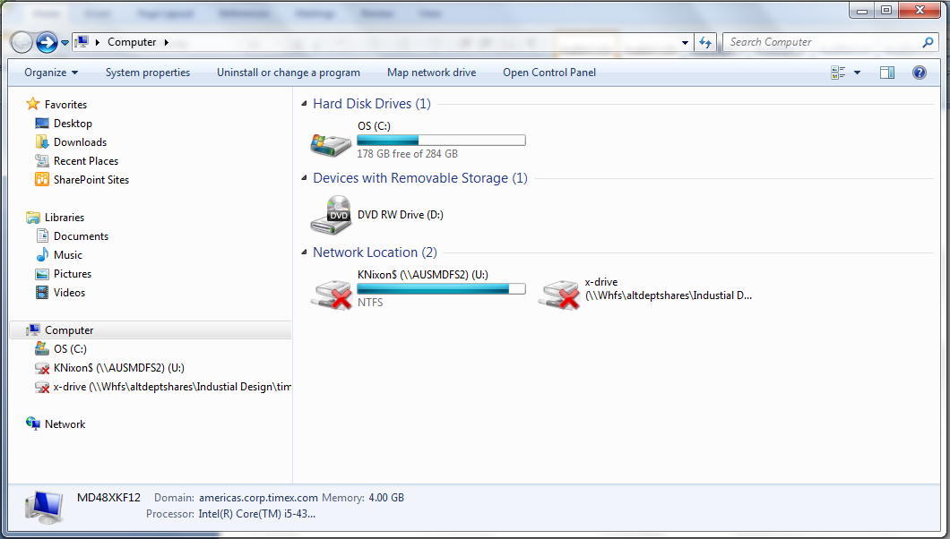System Properties
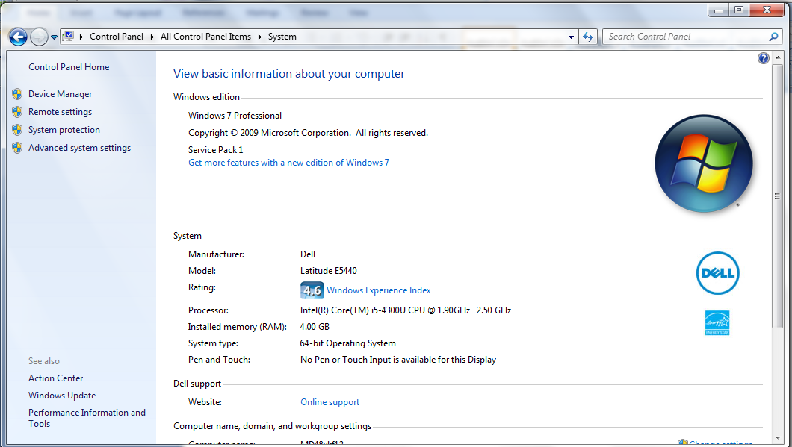System Type

PC App Downloads
There are two download options:
32-bit systems: TimexWindows1.0.9.2(91)_32
64-bit systems: TimexWindows1.1.0.1(95)
These are condensed folders; you will need to extract the contents.
Please install the Timex application.

NOTE:
If you are a Timex employee:
After downloading the appropriate app, you will need to call the IT Help Desk or put in a service ticket. They will log in as an administrator and complete the install for you.

